Assignment for Module 10
The assignment for Module 10 involves problems for schema conversion. Problems 1 to 4 involve the ERD in Figure 1.
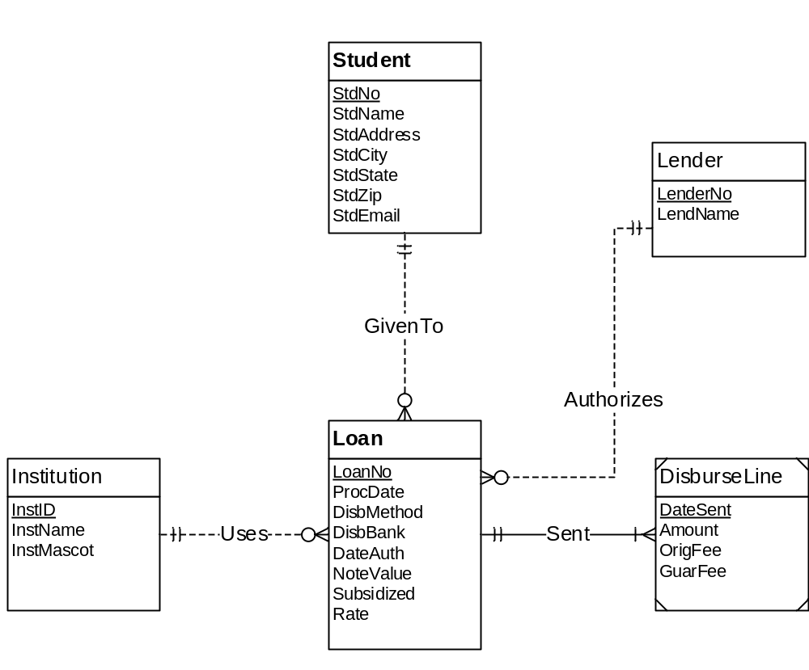
Figure 1: ERD for Problems 1 to 4
1. Requirements for Data Modeling Problems
- For the ERD in Figure 1, you should indicate the applications of the entity type rule. For each entity type rule application, you should identify the table name, primary key, and other columns. You do not need to write CREATE TABLE statements.
- For the ERD in Figure 1, you should indicate applications of the 1-M relationship rule. For each 1-M relationship rule application, you should indicate the changes to the tables you listed in problem 1 including foreign key columns and NOT NULL constraints for foreign keys if necessary.
- For the ERD in Figure 1, you should indicate applications of the M-N relationship rule. For each M-N relationship rule application, you should list the table name, primary key, and other columns.
- For the ERD in Figure 1, you should indicate applications of the identifying relationship rule. For each identifying relationship rule application, you should indicate the changes to the tables you listed in problem 2.
- Convert the ERD shown in Figure 2 into tables. List the conversion rules used and table design. For each table, you should list the primary key, foreign keys, other columns, and NOT NULL constraints for foreign keys if necessary. You do not need to write CREATE TABLE statements.
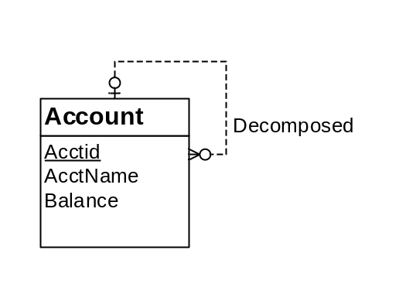
Figure 2: ERD for Conversion Problem 5
- Convert the ERD shown in Figure 3 into tables. List the conversion rules used and table design. For each table, you should list the primary key, foreign keys, other columns, and NOT NULL constraints for foreign keys if necessary. You do not need to write CREATE TABLE statements.
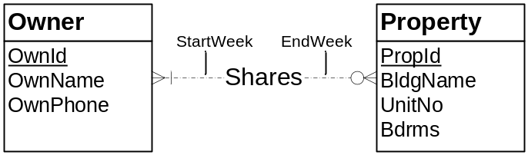
Figure 3: ERD for Conversion Problem 6

2. Submission Requirements
The submission requirements involve evidence that you use the conversion rules for the ERD in each problem. You should label the problems in a document so that the grader can easily match your work to the specified problems. *** Add details about submission ***

